**RESUME**

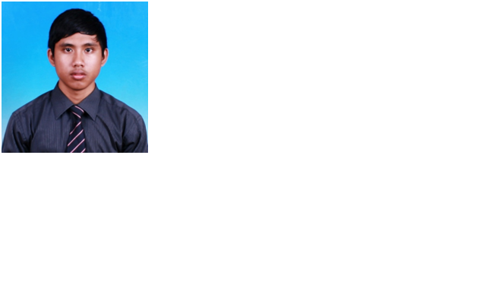

|  |
| --- |
| **Contact Details** |
| Name : MUHAMMAD NAJMIE B. KAMALROZAMAN  Current Address : No.15 Jalan Au4/7 Taman Sri Keramat Tengah Ulu Kelang 54200 Kuala Lumpur  Mobile No. : +60124990511  Email : [m.najmie_k@yahoo.com.my](mailto:m.najmie_k@yahoo.com.my) |
| **Personal Particulars** |
| Date of Birth : 6/9/1991  Age : 26 years old  Gender : Male  Citizenship : Malaysian  Marital Status : married |
| **Additional Info** |
| CAREER OBJECTIVE:  To develop competency and experience in operations field inclusive the related skills in telecommunication such as telecommunication system and networking system. |
| **Educational Background** |
| 1. Diploma In Telecommunication Engineering   Multimmedia College April 2010 - Dec 2012  Related Courses taken : - Telecommunication System  - Advance Circuit  - Control System  - Project management  - Math Engineering  - Electronic Analog  - Electronic Digital  - Microprocessor |
| **Work Experience** |
| * Work at Multiwareless sdn bhd (as Lte DTA engineer) Apr 2015 – Present * Implementation of new features and tuning LTE (4G) radio network parameters * Analysis of neighbor relations and implementation of corrections * Cell and neighbor parameters data fill for new sites and carrier upgrades * New feature and parameter trials and performance reporting * Perform RF performance activities in customer projects independently, according to project plan * Work at Maxis (as RF Engineer ) Apr 2014 – Apr2015 * Optimization of 3G sites based on Coverage RSCP, Quality Ec/Io, Pilot pollution, Missing neighbors, Soft Handover using drive test data’s. Optimize to improve Ec/Io (Reduce Pilot Pollution) by improving RSCP of dominant cells and reducing coverage (Interference) of less dominant sectors through antenna Tilt changes and power changes, thus rectify the overshooting sectors issues. * Analyzing Drive Test reports and providing explanations for poor performance areas. * Analyzing test files on Actix and finding if any issues. * S.M project (as installer and tester ) Jan 2014 – Mac 2014 * Configure S.M Link (Celcom , Digi) * Install new equipment ALCPlus2 and ALCPlus2e * 1 year Work at Radio Frequency Services (M) Sdn Bhd ( as Project Site Supervisor ) Jan 2013 – Dec 2014 * Tester for gabs project NodeB Huawei * Integrated for 4G (maxis) * Installation for new equipment Ericsson to Huawei NodeB (maxis) * User Acceptance Test (UAT) report for 2G,3G,LTE ( Maxis ) * Ericsson project (as Integrator) * Configure from E1 to Ip * User software moshell and hyper terminal * 4 months practical network operation technician at PERNEC (MSAN) April – July 2012 * Certificate for safety * Work At Height (W.A.H) * Niosh * Hirarc |
|  |
| **Language:**Fluent in written and spoken BahasaMelayu  Good in written and spoken English,.  **Computer Skill:** Proficient with MS Office, MS Excel ,MS Power Point, and , Autocad , Nemo Outdoor , Mapinfo , Actix ,TEMS, Genex Probe, Genex Assistant , Nemo Analyze , Google Earth ,Global Mapper.    ADDITIONAL SKILLS:   * Fast learner with minimum supervision * Enjoys outdoor activities * Able to maintain good working relationship with personnel at all level * Have leadership and management skills in leading a team * Able to prepare business proposal * Excellent organizational skill with multitasking ability * Solid working experience with microwave assemblies * Sound knowledge of RF Theory and wireless communications * Familiarity with Analyzers, Signal Generators, Network analyzers * Able to read and follow schematics and wiring diagram |
| **References** |
| 1. Name : Cik Siti Yuszaini Bt Muhamad Hamza   Position : Lecturer Multimedia College  Email : siti.yuszaini.hamzah@mmc.mmu.edu.my  Contact Number: 019-3979885   1. Name : En. Azrul b. Zulkofli   Position : Project manenger Radio Frequency Services (M) Sdn Bhd  Email : azrulzmy@yahoo.com  Contact Number : 019-9977509(Hp)   1. Name : Sri Preakash Sinnappan   Position : Kv Radio Design & Optimisation(Maxis)  Email : ssripre@maxis.com.my  Contact Number : +60173000534   1. Name : Masrizal B Mat Saod   Position : Network Service Quality (Maxis)  Email : msmasri@maxis.com.my   1. Contact Number : +60122040146 |